Bala "Dr. Vish" Viswanathan, M.D.
Breast Surgeon
Specializing in Hidden Scar Breast Cancer Surgery

NEW PATIENT REFERRAL FORM
19260 Stone Oak Pkwy, Suite 102, San Antonio, TX 78258 Tel: 210.545.5455
www.StoneOakBreastSurgery.com

Patient Name Date

Address

City
State
Zip

Phone
D.O.B
Male / Female

Email Primary Insurance

Referring Physician Physician Phone _____________________

Reason for Referral

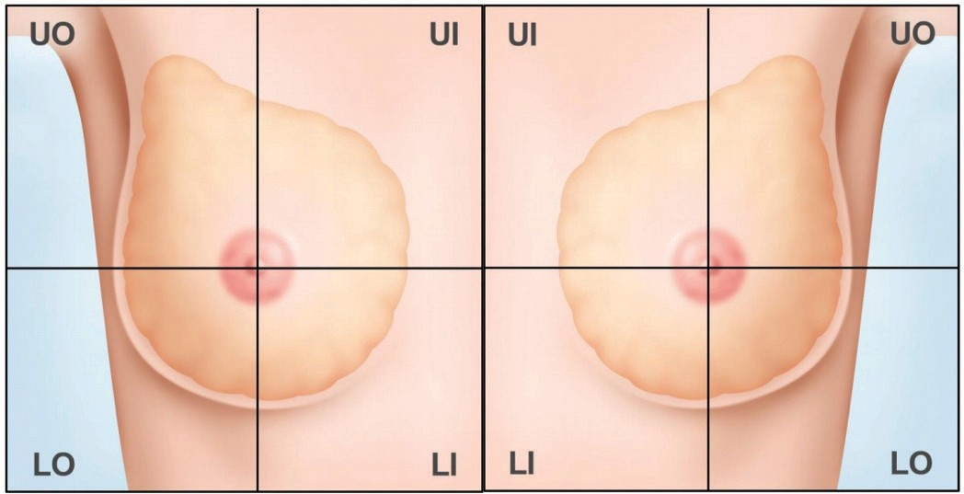
Please illustrate where abnormality was found:

Please fax form to

210.545.0222

Please submit any pertinent medical records

